Self-Serve Trashcans
Food in Classrooms/Conference Rooms
(Do not use for lobby or special event areas)

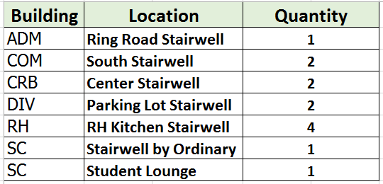

All groups will be responsible to clean up the room and remove trash after each event. Failure to leave the rooms clean and/or take trash to the outside dumpster will incur a minimum charge of $50 from Housekeeping. Trash cans should be returned to the locations noted above per building. Each user must replace the liner after the trash has been emptied leaving the can ready for the next person. Please do not stack the cans.

